Single-Layered Squamous Epithelium—Mesentery
Single-layered (simple) squamous epithelium consists of only one layer of cells. Simple squamous epithelium occurs in the lining of the blood and lymph vessels (endothelium), of the heart (endocardium), the pleura and the peritoneal lumen (serosa, mesothelium). Squamous epithelial cells show a polygonal pattern when viewed from the top. Mesentery tissue, as shown in this picture, consists of flat layers of connective tissue and a layer of serous membranes at each side (visceral peritoneum). The epithelial cells of the serous tissue (mesothelium, peritoneal epithelium) are flat, polygonal cells with short microvilli, which form a single-layered epithelium. In this cuticle preparation, the cells look like pieces on a puzzle board. Silver impregnation has accentuated the cell borders. The borders from underlying cells in this cuticle preparation are visible through the top layer as gray, shadowy lines.

Whole-mount preparation; stain: silver nitrate staining; magnification: x300

Single-Layered Squamous Epithelium—Posterior Epithelium of the Cornea  The surface epithelium is a continuous layer of cells without vessels. Separated by a basal membrane, it is located on top of connective tissue. The apical border is either an inside or an outside body surface. The single-layered squamous epithelium (1) of the cornea, the posterior corneal epithelium (“corneal endothelium”), covers the surface of the cornea opposite to the anterior chamber of the eye. It is a typical single-layered squamous epithelium. A vertical section shows the flat cell profiles. This figure also allows a view of the spindle-shaped nuclei in the flat epithelial cells. Underneath the epithelium is the lamina limitans posterior, Descemet’s membrane (2). This is the thick basal lamina between the flat epithelium and the substantia propria corneae. It is thought to arise from the corneal epithelium. Next to it follows the wide layer of the substantia propria corneae (3). The light spaces are technical embedding artifacts.  1 Single-layered squamous epithelium, endothelium  2 Descemet’s membrane  3 Proper cornea substance  4 Fibrocytes (“cornea cells”)  Stain: hematoxylin-eosin; magnification: x400 | 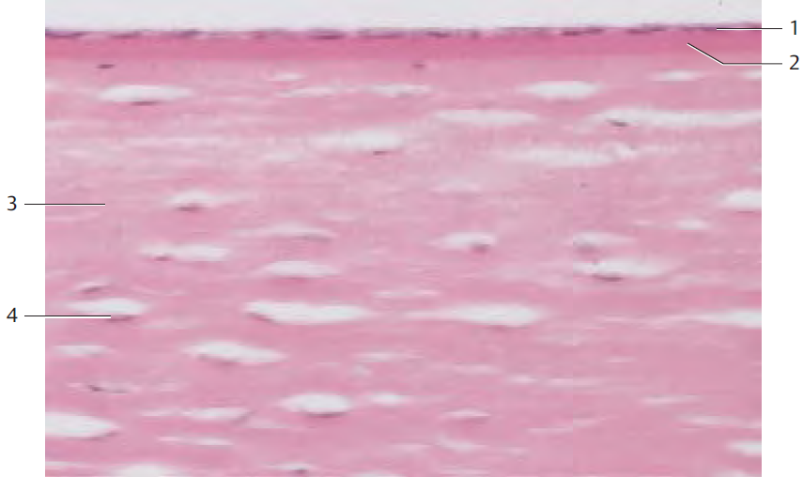
Single-Layered Squamous Epithelium—Posterior Epithelium of the Cornea
View of the posterior epithelium of the cornea at the border to the anterior chamber. The cells are arranged evenly in a polygonal pattern. The cell regions containing the nuclei slightly protrude forward. The surfaces of the layer of flat cells are predominantly smooth. There are no microvilli. The ridged lines are the cell borders where the slender processes of neighboring cells tightly connect and are joined via macula adherentes (desmosomes).

Scanning electron microscopy; magnification: x800

Single-Layered Squamous Epithelium—Peritoneum—Serosa
The peritoneum, the serosa of the peritoneal cavity, consists of a layer of peritoneal single-layered (simple) squamous epithelium and a subepithelial layer of collagenous connective tissue - i.e., the lamina propria serosae. The free surface of the flat epithelium (mesothelium, serosa lining) is covered with microvilli. The cells of the peritoneal epithelium are flat, polygonal cells with serrated cell borders that can be accentuated by silver impregnation. The cell borders in the figure are clearly defined and look like short bars. The nuclei have the shape of lentils. Raised plasmalemma domes indicate their location. The surface above the nuclei has fewer microvilli.

Scanning electron microscopy; magnification: x1650

Single-Layered Cuboidal Epithelium—Renal Papilla  The surfaces of single-layered (simple) cuboidal epithelial cells appear almost rectangular in sections. The basic cell structure is polygonal. In this cross-section of a renal papilla, a collecting duct is cut perpendicularly. It is lined with single-layered cuboidal (isoprismatic) epithelium. The epithelial cells have apicolateral terminal bars (complexes) (1), which are clearly recognizable as heavily stained focal areas. The cell nuclei are round and very heavily stained with eosin. The finely granular cytoplasm and particularly the perinuclear space contain few organelles. There is a thick subepithelial basal membrane (2). Several capillaries close to the collecting duct are cut (3).  1 Terminal bars (complexes)  2 Basal membrane  3 Capillaries  Stain: hemalum-eosin; magnification: x400 | 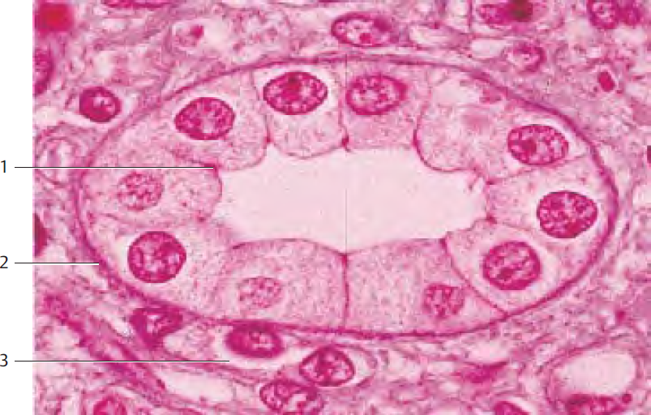
Single-Layered Pseudostratified Columnar (Cylindrical) Epithelium—Renal Papilla  Cross-section through the kidney papilla at the height of the ductus papillares (1). The ducts are lined with single-layered pseudostratified epithelium (cylindrical epithelium, columnar epithelium). The epithelial nuclei (light red) are located in the basal portion of the cell. The cytoplasm contains feworganelles and shows only faint staining. The cell borders are a prominent detail. Between the ductus papillares are blood-filled capillaries (2). The connective tissue components in this renal papilla preparation are stained blue. The diameter for collecting tubes in the ductus papillares is about 20μm.  1 Ductus papillaris  2 Capillaries  Stain: azan; magnification: x200 | 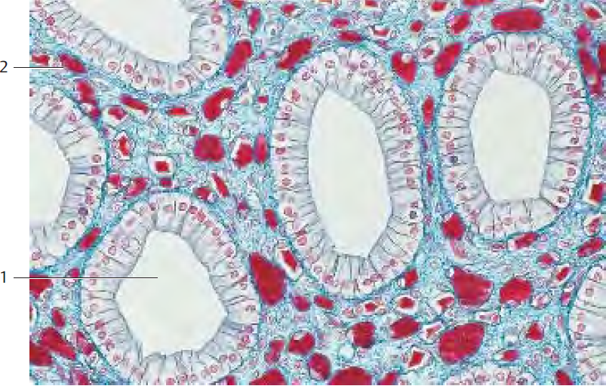
Single-Layered Pseudostratified Columnar Epithelium—Duodenum  In single-layered pseudostratified epithelium, the longitudinal axis of the cells is always oriented vertical to the tissue surface. The cells appear polygonal in cross-sections. A rowof oval nuclei mostly occupy the basal part of the cell, while most of the cell organelles are located in the supranuclear cell region. The free surfaces of the epithelial (enterocytes), cells in this figure have a clearly visible striated border (1) which consists of microvilli. Sporadically, goblet cells (2) occur interspersed with the epithelial cells of the tissue. The cells of the lamina propria mucosae (3) form a connective tissue layer underneath the epithelium, which also contains smooth muscle cells (4), apart from blood and lymph vessels, nerve fibers and myofibroblasts. A thin basal membrane (stained blue in this section) separates the epithelium from the lamina propria mucosae (3).  1 Brush border  2 Goblet cells  3 Lamina propria mucosae  4 Smooth muscle cells  5 Terminal web  Stain: azan; magnification: x400 | 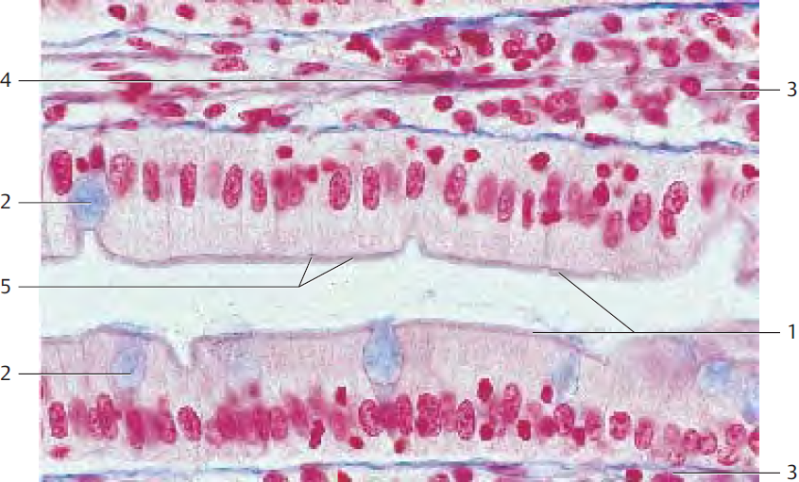
Single-Layered Pseudostratified Columnar Epithelium—Duodenum  Vertical section through the lamina epithelialis mucosae of the duodenum to describe single-layered pseudostratified columnar epithelium (enterocytes). The slender pseudostratified epithelial cells are evenly covered with a brush border (1) (microvilli). The oval nuclei are located in the basal third of the cell. All enterocytes contain a large number of mitochondria, both in the perinuclear (basal) space and in the apical third of the cell (2). Microvilli, here seen as brush border, enlarge the duodenal surface and allow considerably more contact with the intestinal content. Microvilli-associated enzymes are important for the resorption of nutrients and digestion. The lamina propria mucosae (3) is visible in the lower part of the figure.  1 Brush border (microvilli)  2 Mitochondria  3 Lamina propria mucosae  4 Intestinal lumen  Electron microscopy; magnification: x2000 | 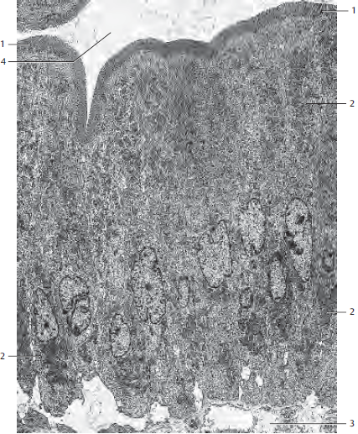
Two-Layered Pseudostratified Columnar Epithelium—Ductus Epididymis  In a two-layered pseudostratified epithelium, all cells originate at the basal membrane. However, not all epithelial cells extend to the surface; the cells have different heights. In this epithelial cell arrangement, the cell nuclei are located at different heights from the basal membrane. This creates the picture of two bands of nuclei (two-layered epithelium). The dark nuclei of basal cells (1) and the lighter, oval nuclei of high columnar cells (2) can be recognized. High columnar cells have long, partially branched microvilli, which stick together at their ends and form spiked stereocilia tops (3) (sperm duct stereocilia). Stereocilia are modified microvilli and contain microfilament bundles.  1 Basal cell nuclei  2 Pseudostratified columnar epithelium cells  3 Stereocilia  4 Connective tissue  Stain: iron hematoxylin-eosin; magnification: x180. | 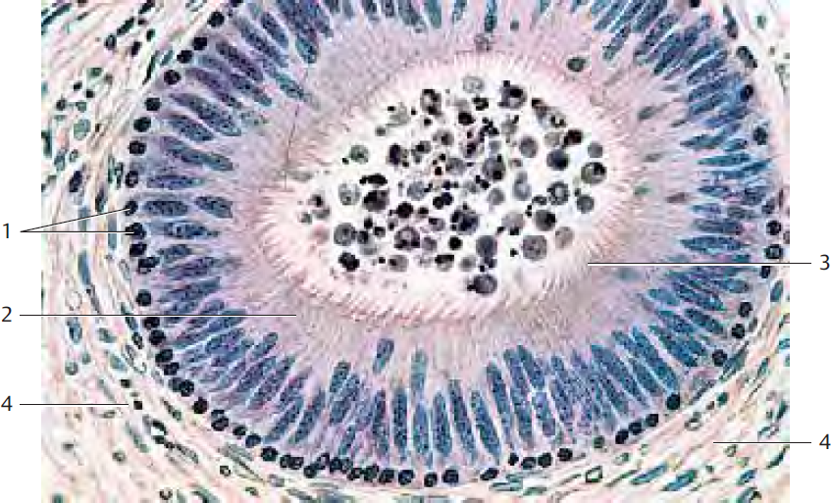
Multilayered Pseudostratified Columnar Epithelium—Trachea  This type of epithelium is characteristic of parts of the respiratory tract (respiratory epithelium). In this form of epithelium, all cells touch the basement membrane but reach different heights. Therefore, the cell nuclei are not only visible in one or two, but at least in three layers. There are small, usually round basal cells (1), intermediary cells in the form of pyramids or spindles (2) and long columnar cells (3). The long columnar cells are ciliated (kinocilia). Heavily stained lines at the apex of cilia cells correspond to rows of basal bodies (4). Underneath the epithelial cells is a thick lamina propria mucosae.  1 Basal cells 2 Surface cells  3 Kinocilia 4 Basal bodies  5 Goblet-cell nucleus 6 Lamina propria mucosae  7 Vessel  Stain: azan; magnification: x400 | 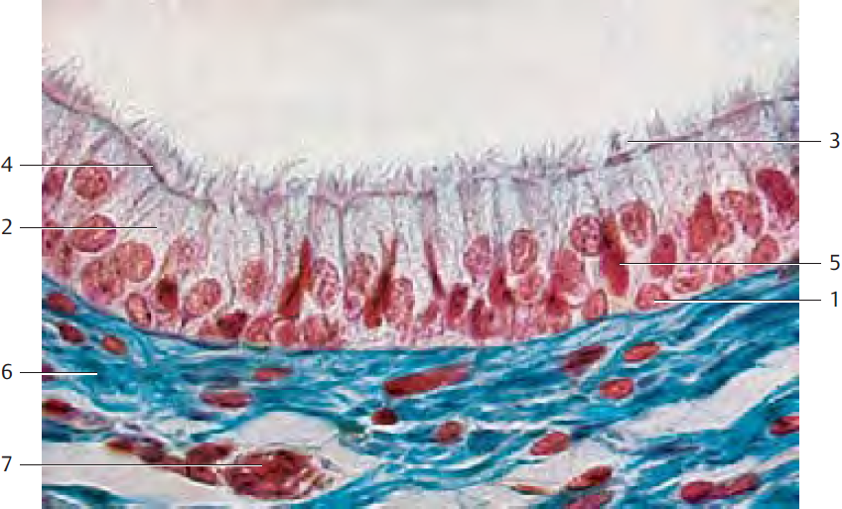
Multilayered Pseudostratified Columnar Epithelium—Larynx  This section through cells from the plica vestibularis more strikingly presents the multilayered structure (banding) of the pseudostratified columnar epithelium (cylindrical epithelium) than the previous section. Intermingled with cells that extend through the entire thickness of the cylindrical epithelium are smaller basal replacement cells (1) and higher intermediary cells (2). The mostly round nuclei of basal cells (1), the oval nuclei of intermediary cells (2), which do not yet reach the surface, as well as the stretched, long nuclei of fully differentiated pseudostratified epithelial cells (3), appear to occupy different layers. Therefore, there are bands with rows of cell nuclei when the epithelium is cut in a right angle to the surface. While all epithelial cells touch the basement membrane, not all of them reach all the way to the surface. Note the row of basal bodies at the apical surface of the tall ciliated cells. Sporadic goblet cells (6) are present amid the epithelial cells.  1 Basal cells 2 Intermediary cells  3 Tall columnar cells 4 Basement membrane  5 Basal bodies 6 Goblet cells  7 Cilia 8 Lamina propria  Stain: azan; magnification: x400 | 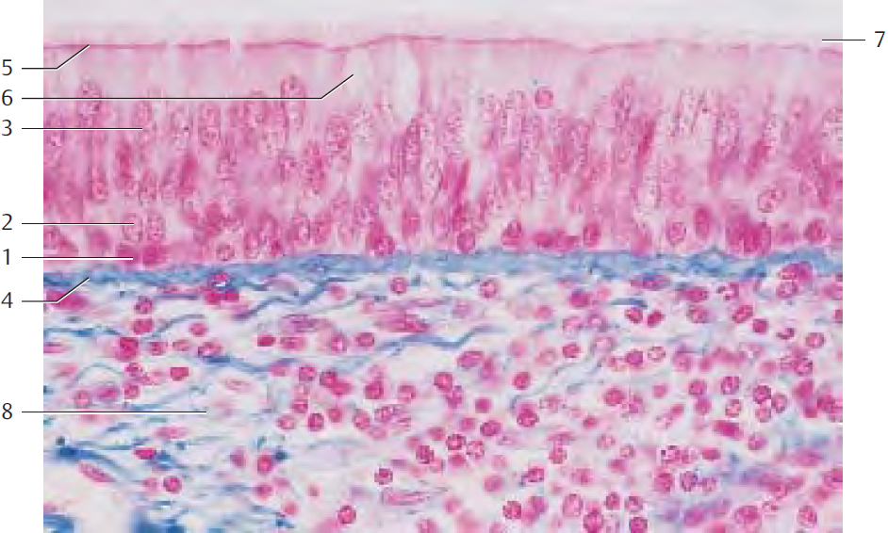
Transitional Epithelium—Urothelium—Urinary Bladder  Transitional epithelium (urothelium) forms a superficial layer, which is specific for the ureters – i.e., for the renal pelvis, ureters, urinary bladder and the initial part of the urethra. The unique characteristic of urothelium is its ability to adapt to volume changes and respond to the tensile forces in the lumen of the urothelium-lined organ. Dependent on the relaxed or distended state of the urinary bladder, urothelium changes its configuration, undergoing a transition from a multilayered type to a type with ostensibly fewer layers (= transitional epithelium). In most instances, at least three layers are present. The layers are identified as the basal layer (1), followed by the intermediary layer (2) and, spanning the intermediary cells like an umbrella, the superficial cells. The cells in the intermediate layer (2), in particular, show irregular shapes, and they are separated by wide intercellular spaces. Polyploid nuclei are characteristic of the superficial cells. There are also superficial cells with two nuclei. Underneath their apical plasmalemma, superficial cells often show a heavily stained area (“crust”). The transitional epithelium has been described sometimes as epithelium with several rows, and sometimes as pseudostratified epithelium.  1 Basal cells  2 Intermediary cells  3 Superficial cell (cells of the superficial layer)  4 Lamina propria  Stain: hematoxylin-eosin; magnification: x400 | 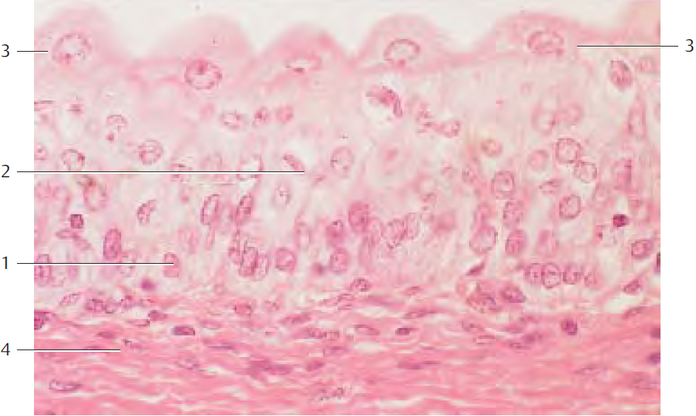
Transitional Epithelium—Urothelium—Ureter  This figure illustrates the basis for the controversy about the configuration of the urothelium. Seemingly, all cells are anchored on the basal membrane. Since they are of different heights, their nuclei appear at different heights from the basal membrane—“multilayered pseudostratified epithelium.” There are basal (1), intermediary (2) and superficial cells (3). Large cells in the superficial layer often have two nuclei. They bulge into the lumen, each one covering several intermediary cells—superficial cells. By definition, the superficial cells must be anchored at the basal layer, if seen as a multilayered pseudostratified epithelium.  1 Basal cells  2 Intermediary cells  3 Cells of the superficial layer  4 Capillaries of the lamina propria  Semi-thin section; stain: methylene blue; magnification: x350 | 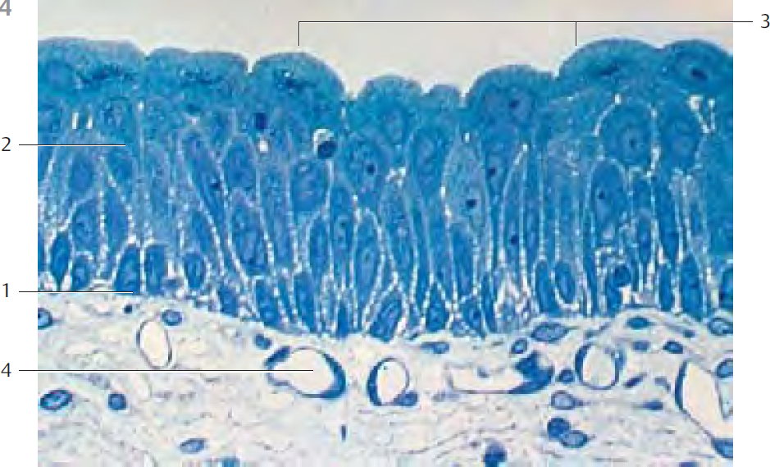
Transitional Epithelium—Urothelium—Ureter
Cross-section through a moderately distended ureter (detail magnification). The transitional epithelium appears as multilayered squamous epithelium. It contains no glands. The superficial cells are flattened (distended). As the bladder expands, the cells of the deeper layers are also flattened. Now, the microfolds at the cell surfaces between epithelial cell junctions are less prominent. Underneath the epithelium, the lamina propria extends as a thick layer of connective tissue with a tightmeshed network of capillaries.

Stain: azan; magnification: x200

Multilayered Stratified Nonkeratinizing Squamous Epithelium—Esophagus  In multilayered stratified epithelium, there are always many stacked cell layers. Only one layer, the basal layer, is in contact with the basal membrane. In the multilayered stratified nonkeratinizing squamous epithelium, the surface cells are flattened, while the cells of the basal layer are seemingly prismatic. In reality, cells of the basal layer have quite irregular shapes. The cells in layers following the stratum basale (1) have polyhedral geometry and are generally larger. In successive layers, cells are more and more flattened, until the largest diameters are measured parallel to the surface. The nuclei are intact even in the top surface layer (2). The dense, dark layer of basal cells is clearly visible because of the heavily stained cell nuclei. The lamina propria mucosae with its high connective tissue papilla (3), (4) is layered underneath the epithelium.  1 Basal layer  2 Superficial layer  3 Connective tissue papilla, across  4 Connective tissue papilla  Stain: hemalum-eosin; magnification: x50 | 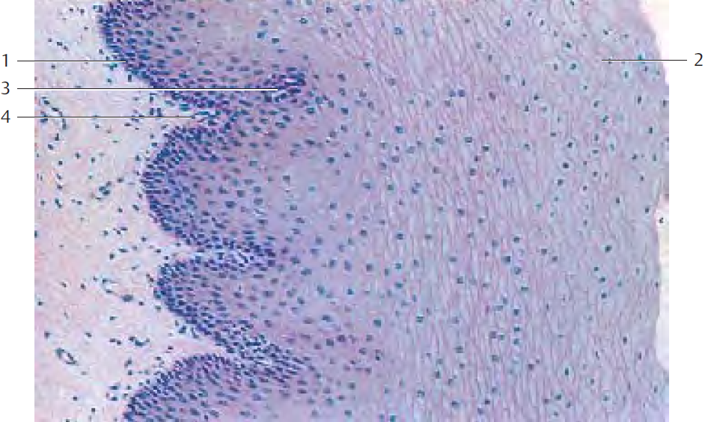
Multilayered Stratified Nonkeratinizing Squamous Epithelium—Cornea  Vertical section through the human cornea with Bowman membrane (1) and substantia propria corneae (2). The anterior corneal epithelium is a typical multilayered stratified nonkeratinizing squamous epithelium (3). It consists of only a few epithelial cell layers. Several epithelial cells are densely layered one over the other. The resulting layers contain basal cells, intermediary cells or superficial cells, respectively. The basal layer consists of prismatic cells; only these are in contact with the Bowman membrane (1). From the basal membrane toward the free surface, the cells are increasingly flattened and are extremely flat at the surface, about 5μm thick and up to 50μm long. The nuclei in these flat surface cells are long and oriented parallel to the surface.  1 Bowman membrane  2 Substantia propria corneae (the crevices are technical artifacts)  3 Multilayered stratified nonkeratinizing squamous epithelium  Stain: hematoxylin-eosin; magnification: x400 | 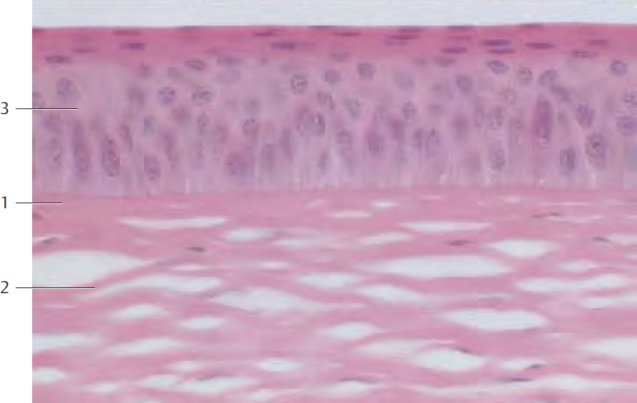
Multilayered Stratified Nonkeratinizing Squamous Epithelium—Plica Vocalis  The plica vocalis (vocal fold) is also lined with a multilayered stratified nonkeratinizing squamous epithelium (1). It forms a rigid attachment to its support. There are no glands in this area. As before, notice the changes in cell shapes in the different layers. The basal cells are between isoprismatic and columnar and border on the basal membrane (2). In the following layers, the cells have polyhedral shapes. Closer toward the free surface, they are more and more flattened until their longest diameter is parallel to the surface. The  two uppermost layers stain intensely.  1 Multilayered stratified nonkeratinizing squamous epithelium  2 Basal membrane  3 Lamina propria  Stain: azan; magnification: x400 | 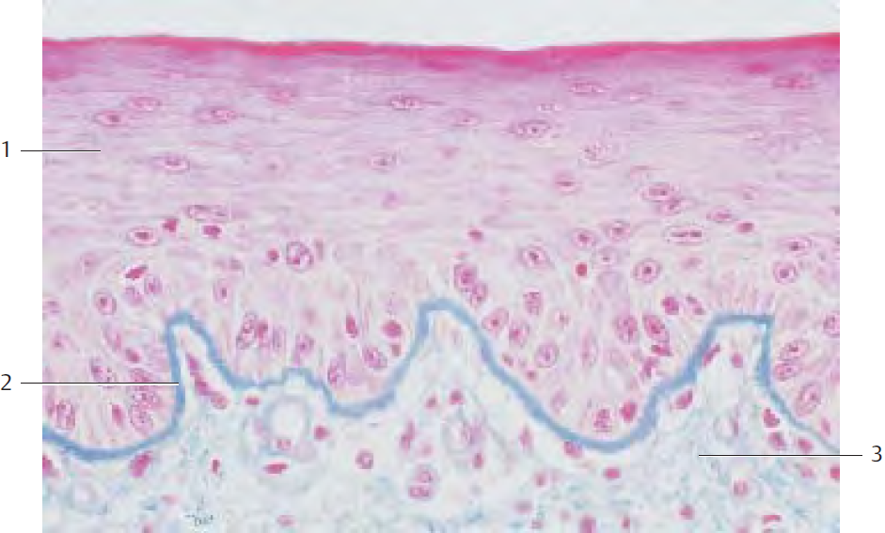
Multilayered Stratified Keratinizing Squamous Epithelium—Vestibulum Nasi  In this form of epithelium, the surface layers go through the process of keratinization. This turns the keratinocytes into a layer of small “dead” keratin scales, the stratum corneum (1). The stratum corneum is only slightly expressed in the vestibulum nasi. In this figure, it is stained light green. Nuclei can no longer be recognized. Underneath the stratum corneum is a layer of cells with dark cytoplasmic granula. It is termed stratum granulosum. Underlying this layer, follow several layers of prickle cells, the stratum spinosum. Again, only the cells of the basal layer have contact with the basal membrane. Stratum basale and stratum spinosum combined form the germinative layer, the stratum germinativum. Under the epithelium is the lamina propria, with bundles of collagen fibers and many vessels (2).  1 Stratum corneum 2 Vessels of the lamina propria  Stain: iron hematoxylin-benzopurpurin; magnification: x135 | 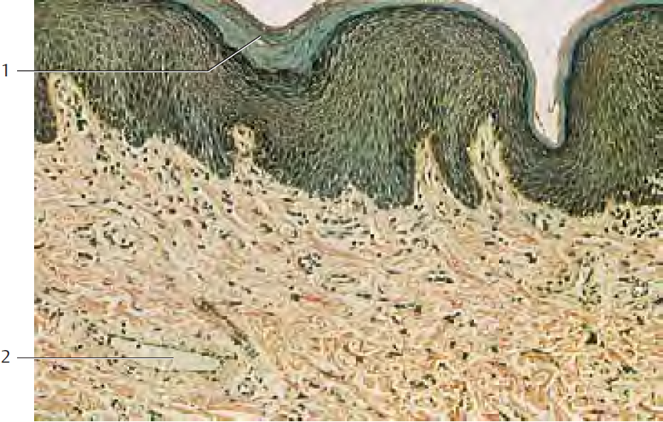
Multilayered Stratified Keratinizing Squamous Epithelium—Axillary Skin  Skin thickness varies for different parts of the body. For example, the epidermis of the palm and the soles is thick. However, the thin skin of the back, for example, has a strikingly thick corium (dermis). Skin is thinner and less cornified if not stressed very much. The epidermis in this figure consists of only a few cell layers and furthermore, the surface relief reveals reserve folds. The stratum corneum (1) is relatively thin. In this case, the keratin layers are already loosened and form scales, which will scuff off. Up to 16 g of keratin scales may be scuffed off daily. Skin in the armpit.  1 Stratum corneum 2 Dermis (corium)  Stain: hematoxylin-eosin; magnification: x130 | 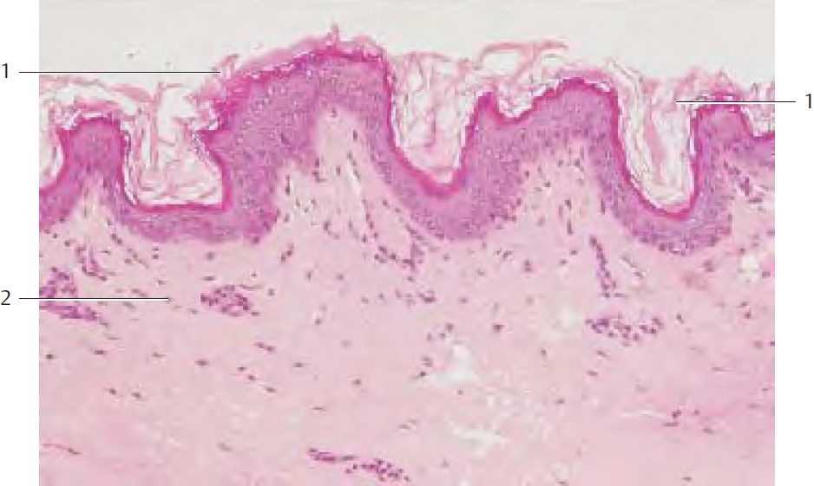
Multilayered Stratified Keratinizing Squamous Epithelium—Palm of the Hand  The palm of the hand is subject to considerablewear and tear. Because of this stress, the epidermis is tightly attached to the dermis (corium). The epidermis also consists of more layers and is more cornified than the thin epidermis. Note the thick stratum corneum (1) , the abundant epidermal processes (2) and the configuration of the corium papillae (3) . Intact cells with nuclei do not exist in the stratum corneum (keratin layer).  1 Stratum corneum 2 Epidermal projections  3 Corium papillae 4 Dermal stratum papillare  Stain: Masson-Ladewig trichrome staining; magnification: x80 | 